**Objectway SaaS - MS Azure AD - Logon instructions**

**MOBILE APP OPTION**

**Intro**

This document provides the logon instructions for accessing your Objectway application(s) using MS Azure AD and its Mobile (token) App (Android or iOS).

In the first section, the activation of the user and password set up is described. In the second section, the first (and second) logon methods are described.

Please note that a user id and access token are personal and may never be shared with others.

**Section 1: Activating your MS Azure AD account**

**Step 1.1: Link**

Use the following link to set your password: <https://aka.ms/sspr>

* Fill out your user id provided to you via e-mail.
* Fill out the characters shown in the picture (it’s case sensitive).

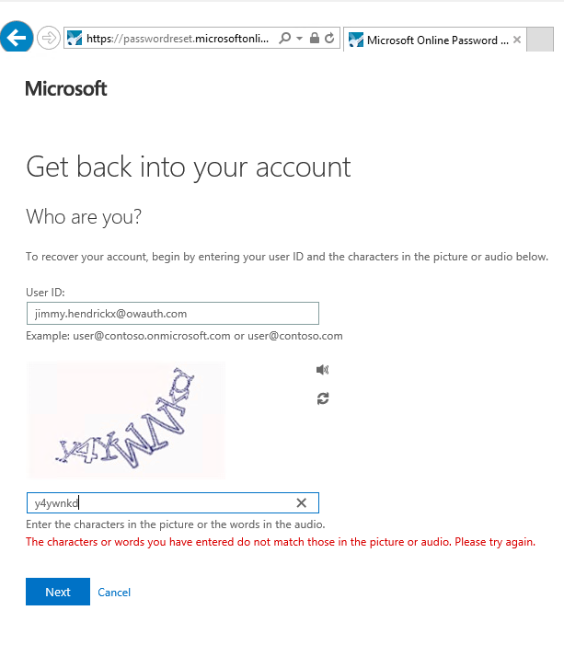

* Click **Next** to continue.

**Step 1.2: Verify your account**

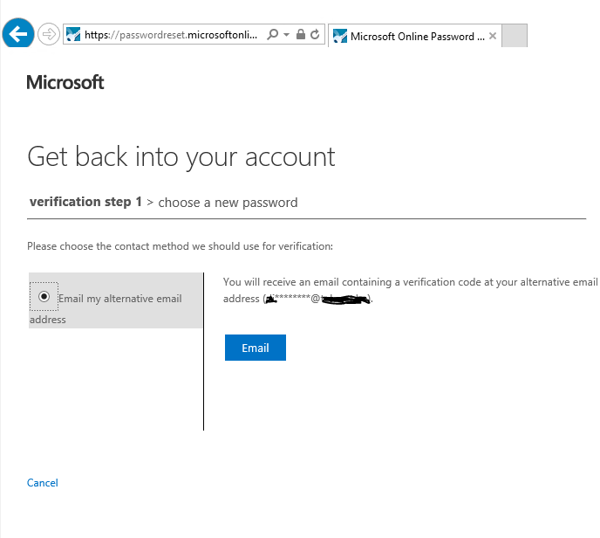

* Click **Email** button to continue.
* You’ll receive an e-mail to the address provided containing a security code:

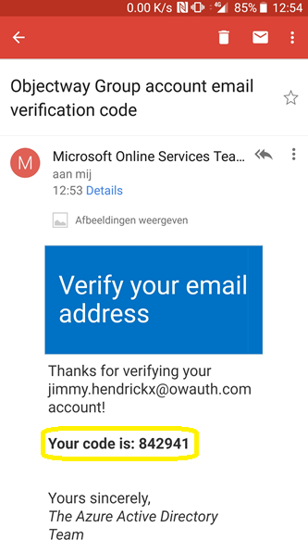

* Once you received the e-mail with the code, fill this out in the next screen:

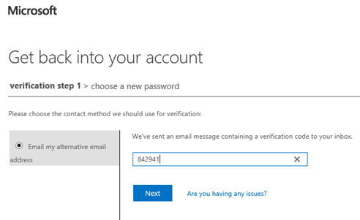

* Click **Next** to continue.

**Step 1.3: Set password**

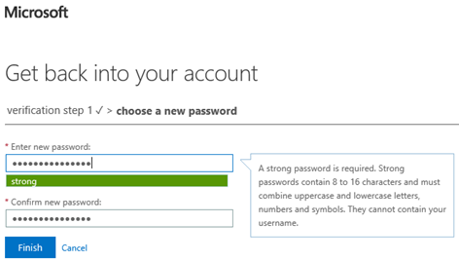

* Fill out your preferred password, complying to the rules as explained on screen. Please note, an exclamation mark is not recognized as a symbol.
* Click **Finish** to finalize. The following screen will be shown:

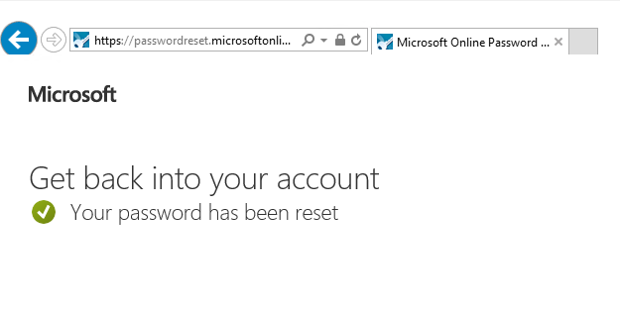

* You’ll get a notification that your password was set correctly.

The first section is now completed.

**Note:** If you don’t adhere to the password policy you’ll be asked to fill out the password again.

**Section 3 Installing MS Authenticator app**

Go to the Apple or Google app store on your smartphone to download and install the ‘Microsoft authenticator’ app:

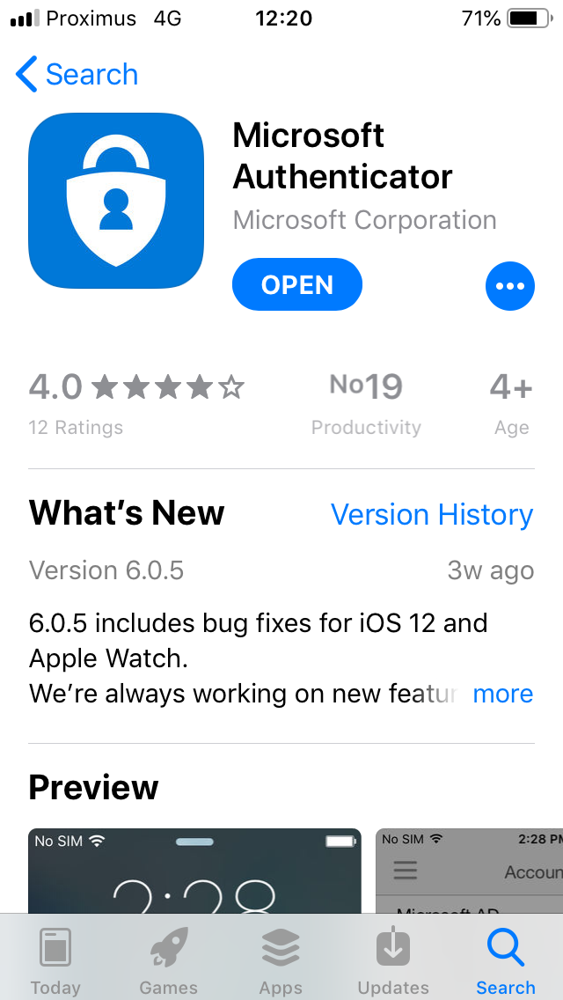

You can also use the following links to access the app link on your smartphone:

* Android: <https://play.google.com/store/apps/details?id=com.azure.authenticator&referrer=adjust_reftag%3Dc9fgd4hk17nhG%26utm_source%3DMFA%2BSetup%26utm_campaign%3Dappstore_android>
* iOS: <https://itunes.apple.com/app/microsoft-authenticator/id983156458?mt=8>

**Section 4 First logon procedure**

**Step 4.1: Logon to environment**

Open eXimius using the provided url:

* In the following **sign-In** screen fill out the user id ([xxx@owauth.com](mailto:xxx@owauth.com)) provided.

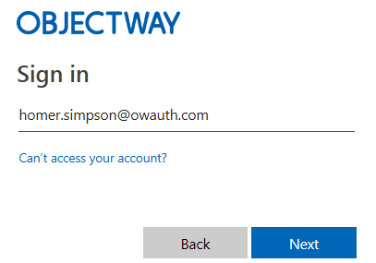

* Click **Next** to continue.

* Fill out your password (the one you’ve created in the **Activating your MS Azure AD account** procedure).
* Click the **Sign in** button to continue.

You’ll now see a screen to enter additional information before you can continue.

* Click **Next** to continue.

**Step 4.2: Additional Security verification**

You’ll see a screen asking to complete the ‘**Additional security verification’**.

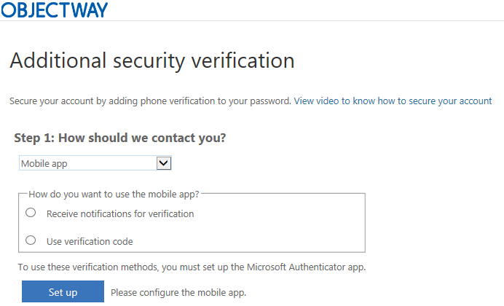

* Select **Mobile app** in the drop-down box**.**
* Select one of the 2 options:
  + **Receive notifications for verification**: With this option you need to confirm the code in the mobile app and logon will continue seamlessly. No need to re-type the code at logon.
  + **Use verification code**: In this option you need to enter the code shown in the mobile app during logon.

It is recommended using the **Use verification code** option since this requires you to always enter the code during logon.

* Press **Set up.**

The following screen will be shown:

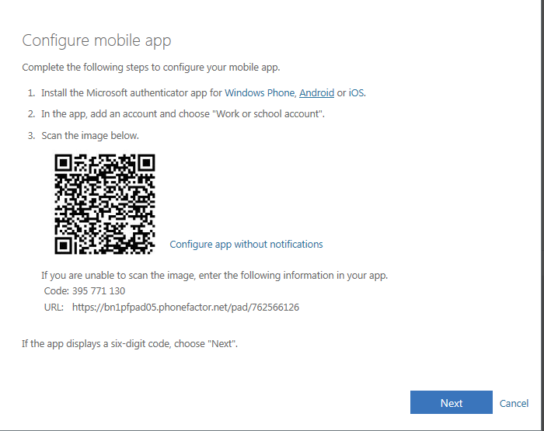

* You should have the MS Authenticator app installed already (see **Installing MS Authenticator app)**

Open your MS Authenticator app:

* Add an account by pressing the + sign.

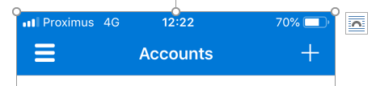

* Select Work or school account.

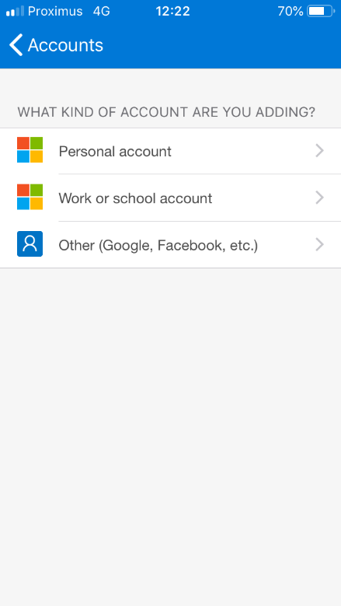

* When you only want to use verification codes (and no notifications) press **‘Configure app without notifications’** (A new QR code will be generated).
* Use the MS Authenticator app to scan the QR code shown on the screen to activate and register your account.
* The app should now show your Objectway Group account with a code being refreshed every 30 seconds:

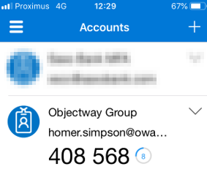

* Note: You must scan the QR code within 2-3 minutes otherwise the code will become inactive, and an error is shown. In this case press Cancel and press Setup again.
* Press **Next** to continue.

The following screen is shown to indicate your mobile app and account is now configured for notification and verification codes.

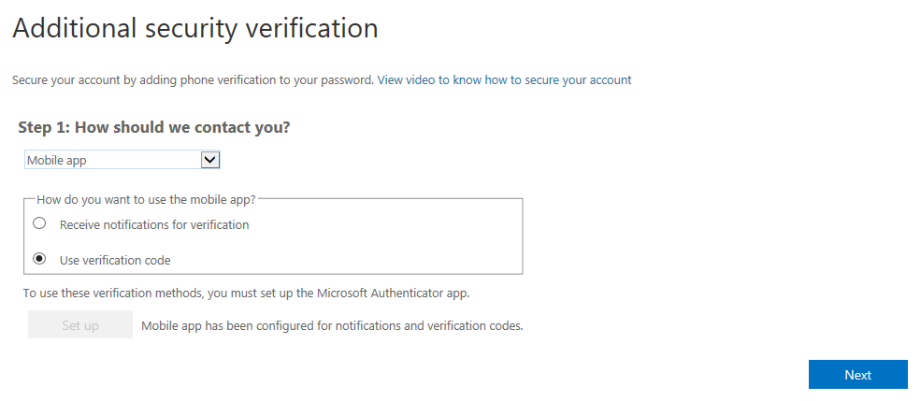

When you’ve disabled notifications the screen message looks like:

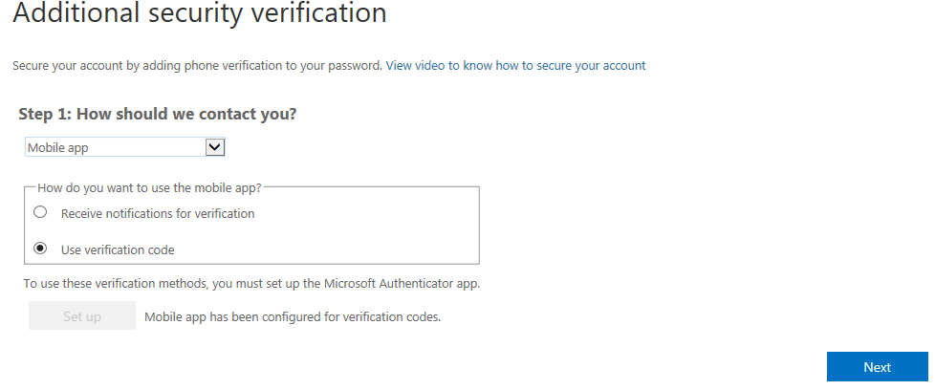

* Press **Next**.

Case 1 - When the verification code option has been chosen, enter the code shown in your MS authenticator app in the below screen:

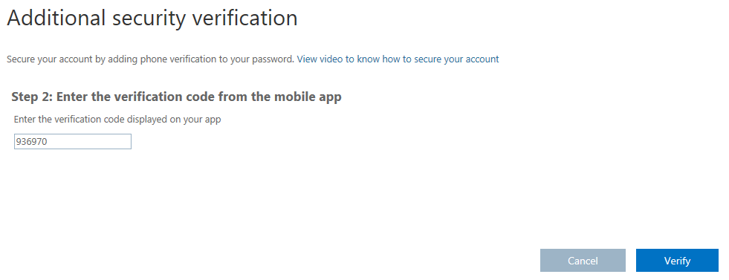

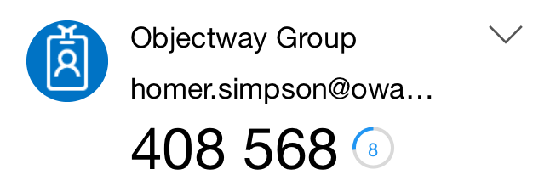

Case 2: When the notifications options was selected approve the code shown in your authenticator app to continue:

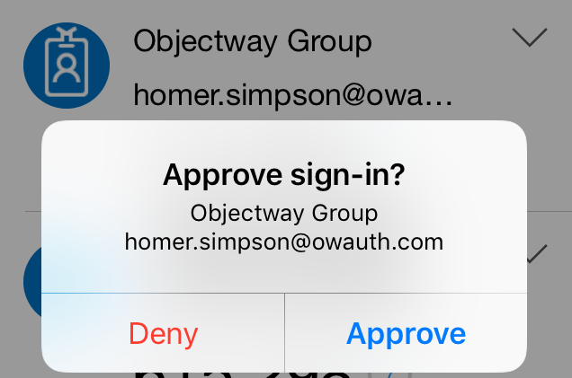

* Press **Verify**.

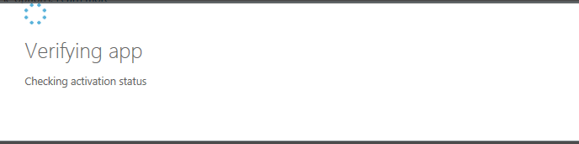

A **progress screen** is shown.

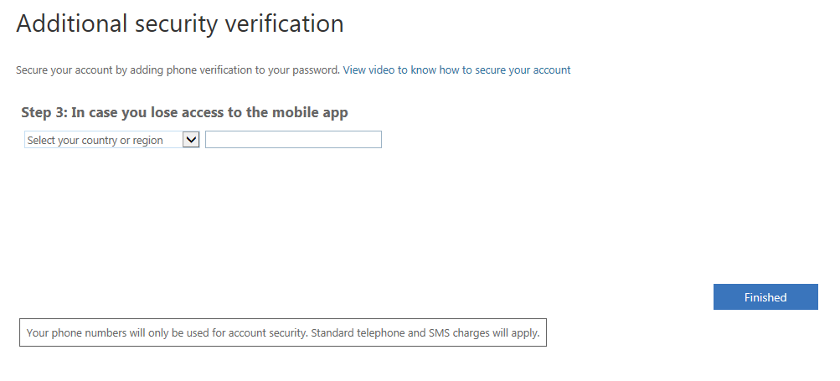

* In the last step you’re asked to enter a phone number (landline or mobile). Please note this will only be used in case you lose access to your mobile phone and/or its app (during change password).
* Select your country and enter your phone number
* Press Finished.

You’ll now be logged on to eXimius SaaS.

**Section 5 - Logon procedure**

When opening the eXimius url:

* In the **sign-In** screen fill out your user id ([xxx@owauth.com](mailto:xxx@owauth.com)).

* Click **Next** to continue.
* Fill out your password.

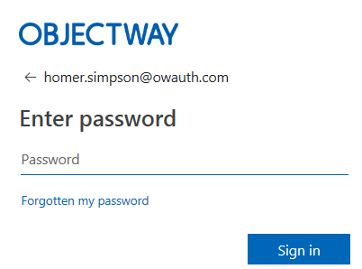

* Click **Sign in** to continue.

Case 1 - When you’ve decided to use verification codes enter your code:

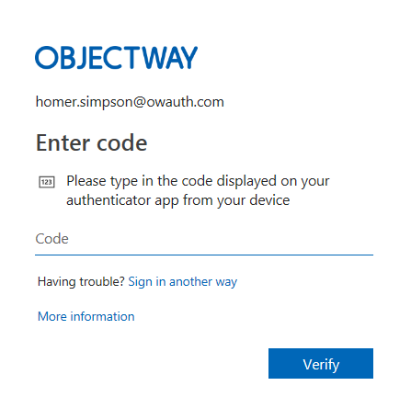

* Enter your code as shown in your MS Authenticator app for your account.
* Press **Verify**.

Case 2 - When you’ve opted to use notification approve your code:

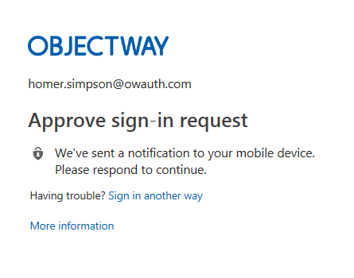

* Press Approve in your MS Authenticator app when asked.



After validation the eXimius application will be opened.

**Section 6 – Optional procedure – How to change or add my authentication method**

*This is an OPTIONAL section. This can be skipped accordingly.*

You might want to use this section when:

* You currently authenticate via sms (text) but would like to use the MS Authenticator app.
* You currently use the MS authenticator app with verification but want to use notifications.
* You want to remove either the sms or MS Authenticator app option.
* To set your preferred authentication method.

**Step 6.1: Logon to MFA Setup tool**

Use the following link to use this tool: <https://aka.ms/mfasetup>



* Select or fill out your user id.
* Press **Next**.



* Fill out your password.
* Press **Sign In**.

Depending on your current authentication method you’ll be asked to enter/confirm your code using your mobile authentication app or use the code send by sms/text.

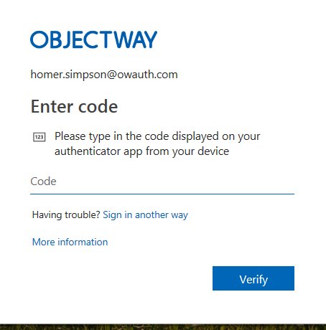

* Press **Verify**.

You’ll see the following screen:

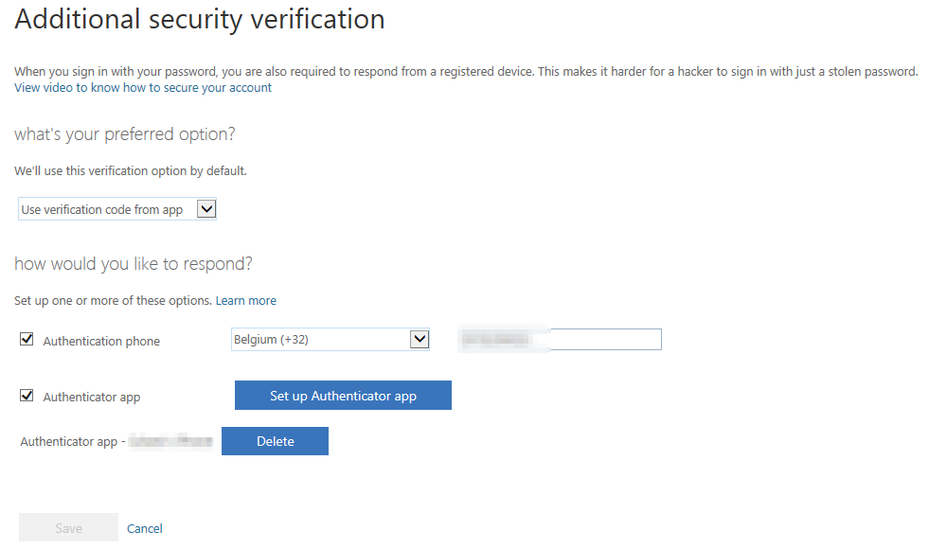

**Step 6.2: Changing your preferred authentication method**

From the tool’s drop-down box select your preferred method:

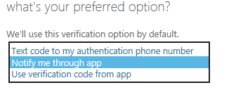

Possible options:

* Text code to my phone: To receive your code via text/sms message.
* Notify me through app: This requires the MS authenticator app and for you to confirm the code.
* Use verification code from app: This requires the MS authenticator app and you to enter a code during logon.
* Press **Save**.

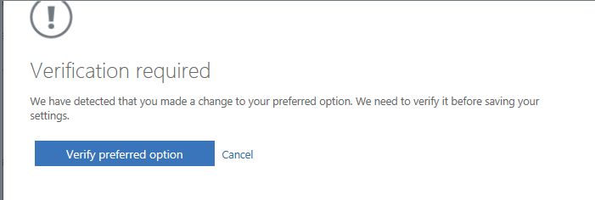

When your authentication method is changed the above screen is show.

* Press **Verify preferred option** and follow the on-screen instructions to verify your new preferred authentication method.
  + Note: changing preferred method to sms does not always trigger a new sms message to confirm.

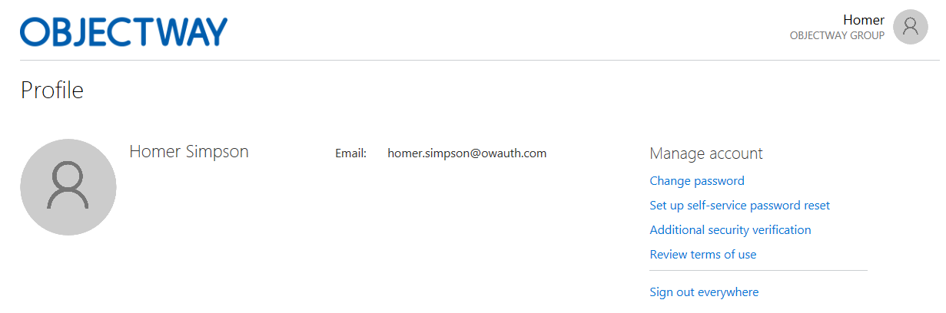

* Press **Sign out everywhere**
* Press **Yes**.

**Step 6.3: Remove sms/text or mobile app option for authentication**

Using the tool deselect either the Authenticator app or Authentication phone and press **Save**.

You might get an error when removing an option which is still set as your preferred option. In that case please change so accordingly.

**Step 6.4: Enabling the mobile authentication app on your existing account**

When you currently only have the sms/text option enabled, or would like to use the MS Authenticator for authentication, you’ll see a screen like:

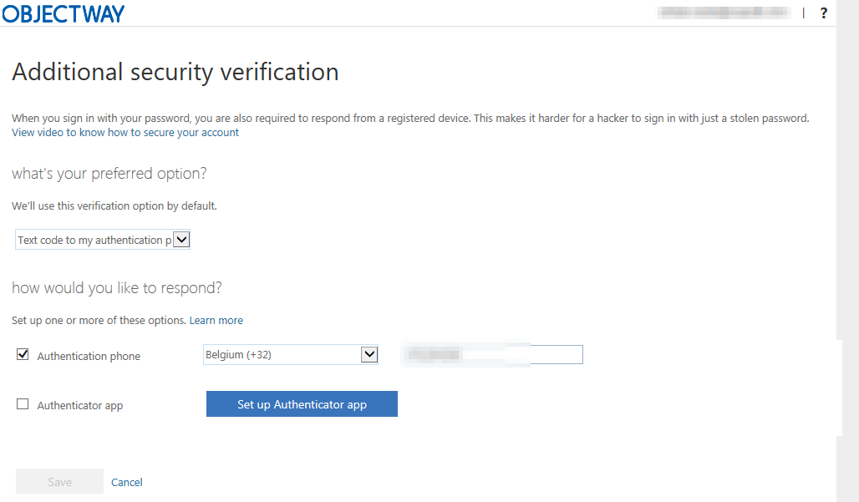

If you have not yet installed the MS Authentication app see section ‘Installing the MS Authenticator app’

* To start using the MS Authenticator app select **Authenticator app**.
* Click **Set up Authenticator app**. The following screen is shown:

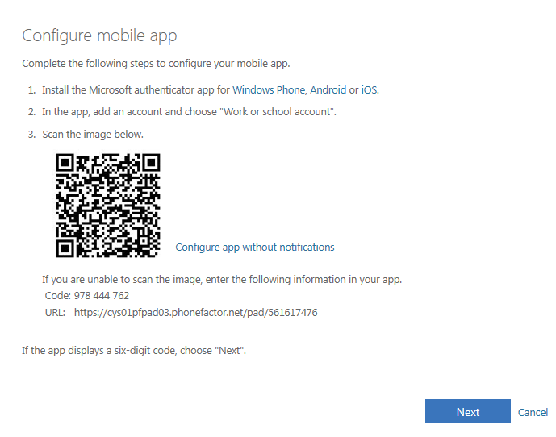

Open the MS Authenticator app on your smartphone:

* Add an account by pressing the **+** sign.



* Select **Work or school account**.

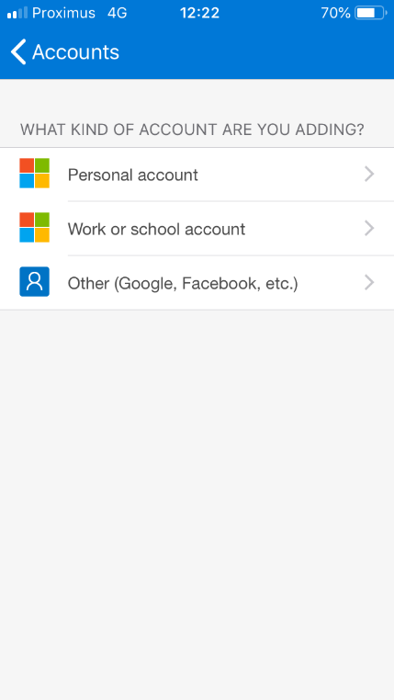

* When you only want to use verification codes (and no notifications) press **‘Configure app without notifications’** (A new QR code will be generated).
* Use MS Authenticator app to scan the QR code shown on the screen to activate and register your account.
* The app should now show your Objectway Group account with a code being refreshed every 30 seconds:



* Note: You need to scan the QR code within 2-3 minutes otherwise the code will become inactive and an error is shown. In this case press Cancel and press Setup again.
* Press **Next** to continue.



A progress screen is shown.



* Press **Approve** in your MS Authenticator app when asked.
* Note: When you’ve opted to use verification code you need to enter the verification code instead.

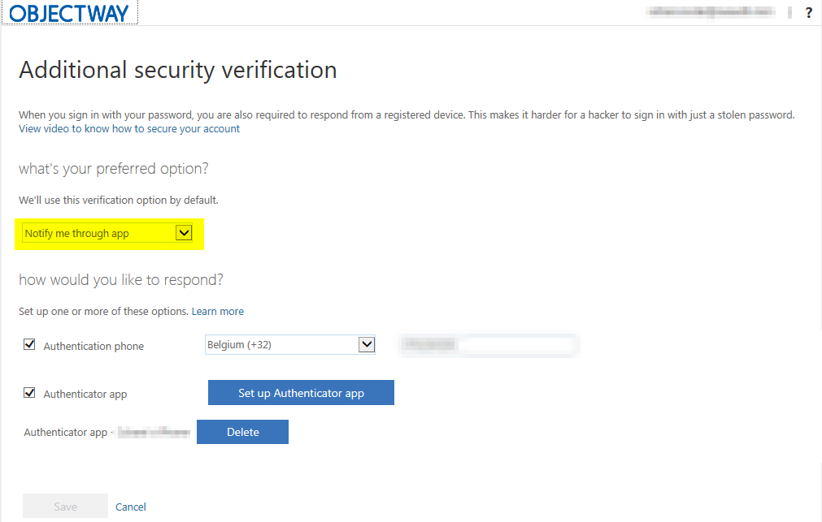

* Set your preferred authentication option to either **‘Use verification code from app’** or **‘Notify me through app’**.
* Press **Save**.

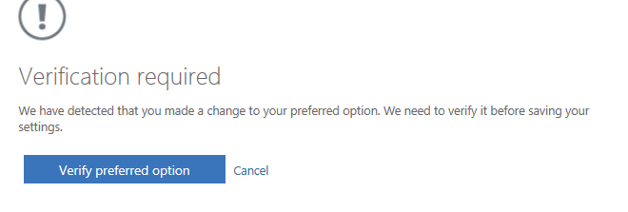

* Press **Verify preferred option**.



* Press **Approve** in your MS Authenticator app when asked.
* Note: in case of verification code you must enter verification code instead.

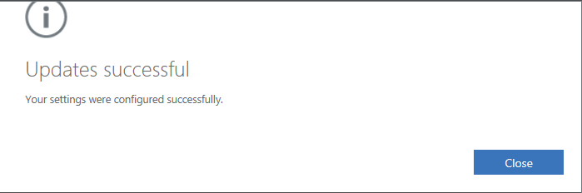

* Press **Close** in the following screen.
* Press **Sign out everywhere** in the next screen**.**
* Press **Yes**.

**Step 6.5: Changing mobile authenticator app from verification code to notification (or vice versa)**

In this option your MS Authenticator app is already registered.

* Click **Set up Authenticator app**.

Follow the instructions on the next screen (no need to download the app again).

When you no longer want to use notifications via authenticator app but verifications press **‘Configure app without notifications’** first.

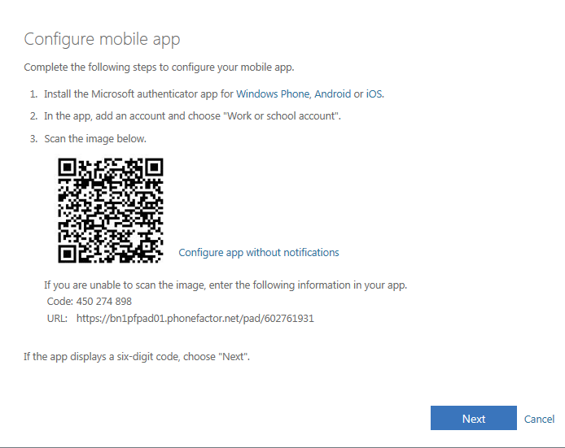

* Press **Next**.
* You’ll receive a notification in your MS Authenticator app.



* Select **Approve** in your MS Authenticator app.
* Note: When you’ve opted to use verification code you must enter verification code instead.

Your authentication method is now being reset to MS Authenticator app via notifications or verification codes. Please note that the re-activation progress window can take several minutes (please wait for it to complete). It can happen an error is returned at this stage indicating reset takes longer than expected. In this case wait 15 minutes and logon to Objectway’s Cloud application to see if your authentication method has been changed correctly.

**Step 6.6: Deleting your authenticator app from your user account**



* Press the **Delete** button next to your authenticator app and follow the onscreen instructions.

**Troubleshooting FAQ**

**When trying to logon to eXimius I see a Microsoft selection box asking me to select an account?**

This MS account selection is shown when you’re using different MS cloud-based solutions like MS Office 365 (since they also use MS Azure AD). In that case select ‘Use other account’ to logon to eXimius. It’s recommended not to logon in other MS cloud solutions (e.g. Office 365) via the same browser window with a different account.

**MS Azure AD does not seem to accept my password?**

Your MS Azure AD password must comply with the following password rules:

* A minimum of 8 characters and a maximum of 16 characters.
* Strong passwords only requiring three out of four of the following:
  + Lowercase characters.
  + Uppercase characters.
  + Numbers (0-9).
  + Symbols (see the previous password restrictions).
* Different from your previous password.

**How do I initially register my mobile phone app to receive my access code for logon?**

Using the procedure explained above in topic ‘First Logon procedure’.

**My phone changed (or I lost access to the mobile app). How can I update this on my account to receive access code?**

Please contact our Service helpdesk to reset your account allowing you to re-enter initial details and register mobile app during the next logon.

**Can I use my email address to receive my access code during logon?**

No, this is not supported. From a security perspective it’s recommended using a 2nd device to receive the access code.

**The following error is shown 'An error occurred’.**

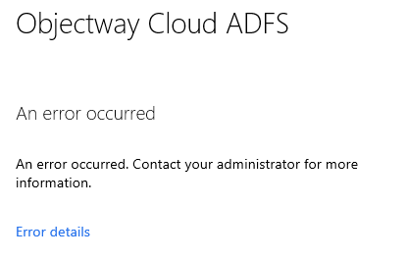

Please verify you’ve entered the correct username, password, and access code. When the error persists close all browsers and try again. Additionally, cleanse your browser cache. When the above does not resolve the error please contact our helpdesk.

**The following error is shown ‘<User not known in the application>’.**

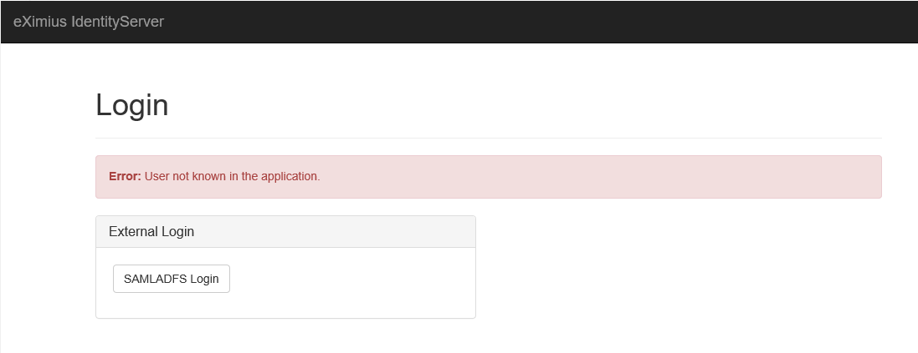

This means your user id is not setup correctly in eXimius, please contact our helpdesk.

**Will my password expire?**

Yes, your password will expire after 90 days and a new password must be entered.

**I think my MS Azure AD account or password is locked.**

After 5 unsuccessful sign-in attempts the user is locked out for 1 minute. Further incorrect sign-in attempts lock out the user for increasing durations of time.

**How can I change my password?**

Option 1: On the logon page select ‘Forgotten my password’ to change your password.

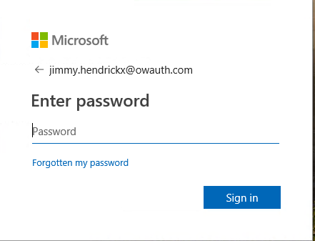

Option 2: Use the link <https://aka.ms/sspr> as described in the **Activating your MS Azure AD account** procedure.

**The following message is shown ‘<Your account has been locked out.>’.**

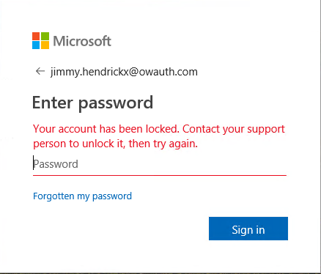

This means your account was administratively disabled. Please contact our helpdesk.

**How can I change my authentication method to use the mobile app or change my preferred password?**

See section 6 – Optional procedure – How to change or add my authentication method.

**Support details**

If you have any questions , please get in touch with our Customer Support Team. They will gladly offer their assistance.

* Tel: +32 2 448 01 06
* Mailbox: [customersupport@kbc.be](mailto:customersupport@kbc.be)